**EXP28 DECIMAL TO HEXADECIMAL NUMBER**

PROGRAM:

int main() {

long int decimalNumber,remainder,quotient;

int i=1,j,temp;

char hexadecimalNumber[100];

printf("Enter any decimal number: ");

scanf("%ld",&decimalNumber);

quotient= decimalNumber;

while(quotient!=0)

{

temp = quotient%16;

if(temp < 10)

temp =temp + 48; else

temp = temp + 55;

hexadecimalNumber[i++]=temp;

quotient= quotient / 16;

}

printf("Equivalent hexadecimal value of decimal number %d: ",decimalNumber);

for(j = i -1 ;j> 0;j--)

printf("%c",hexadecimalNumber[j]);

return

0;

}

INPUT:

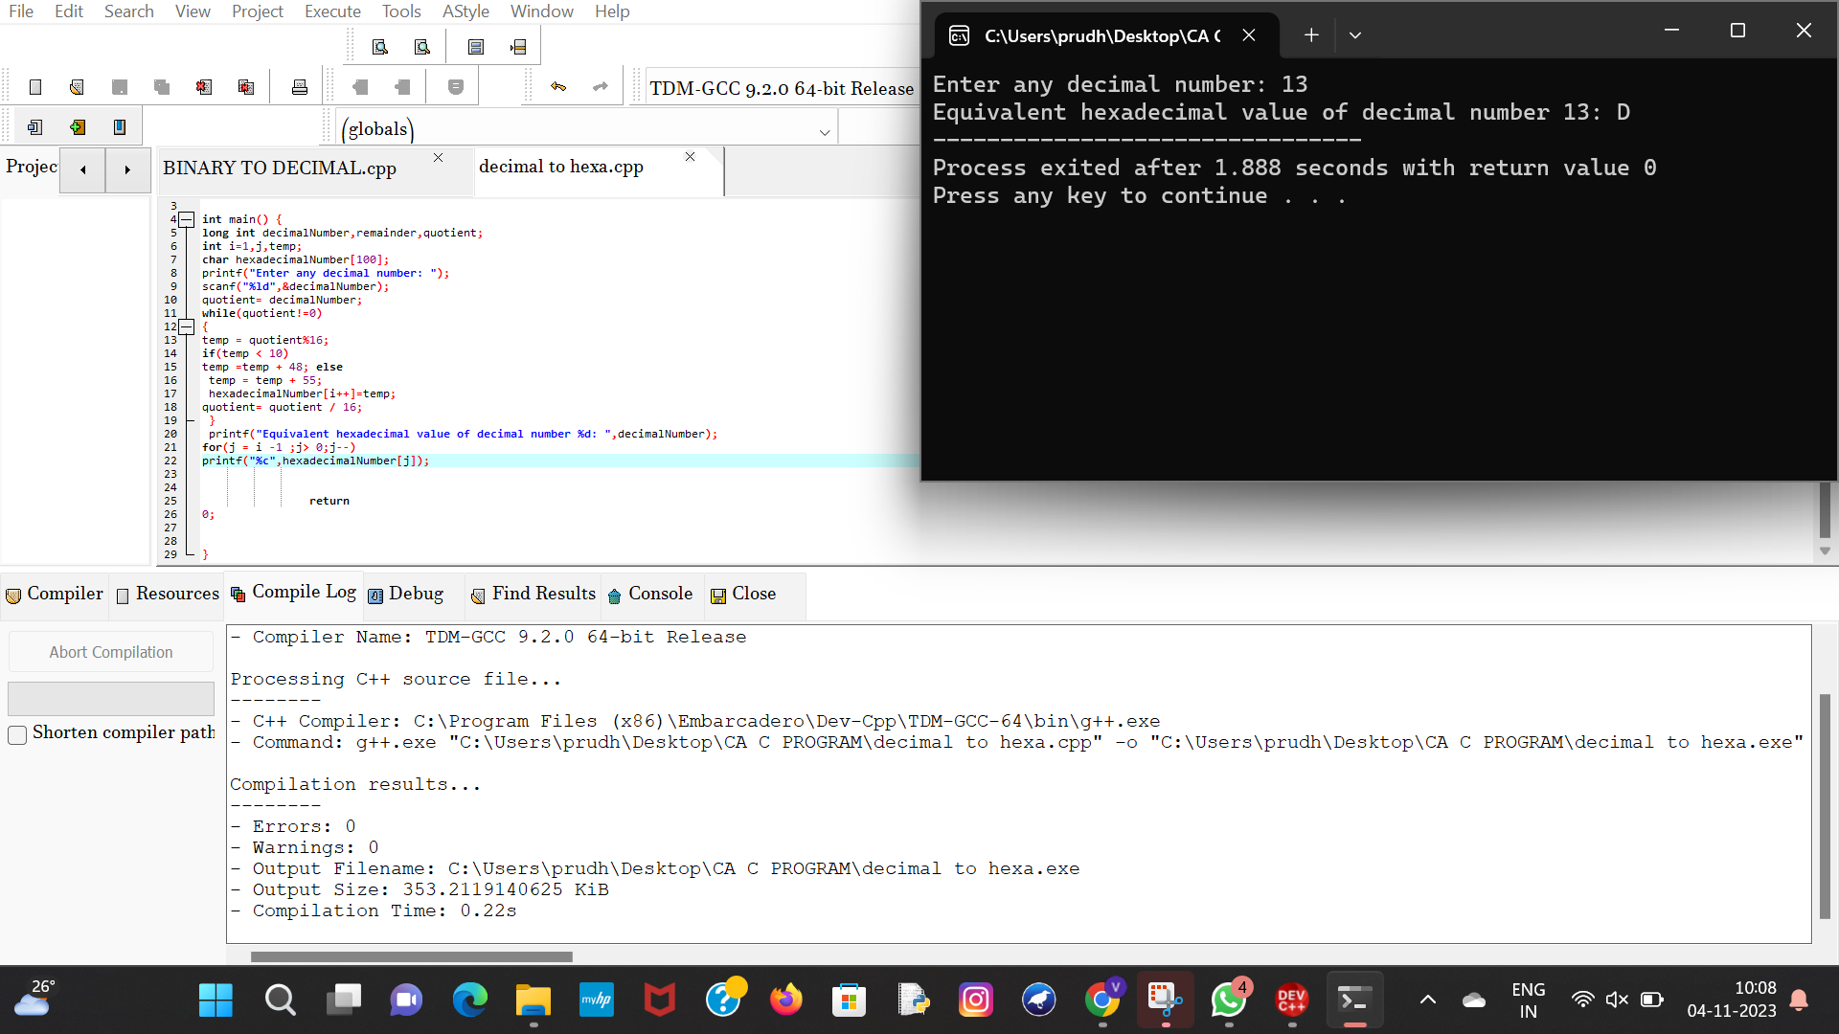

OUTPUT:

